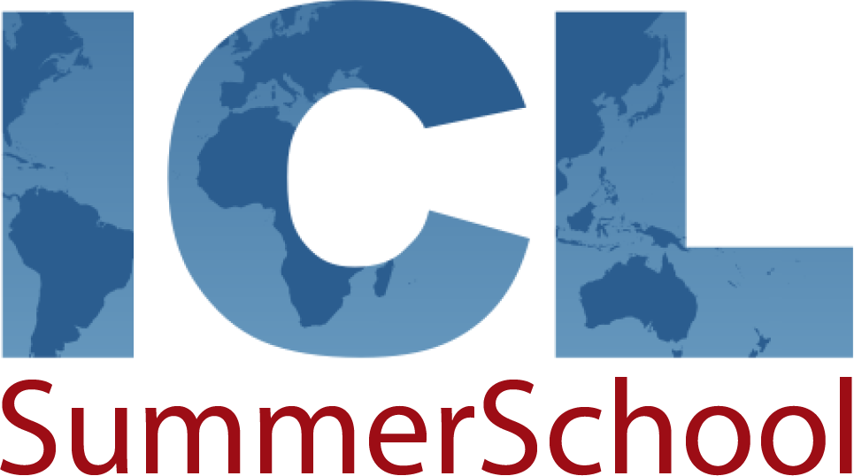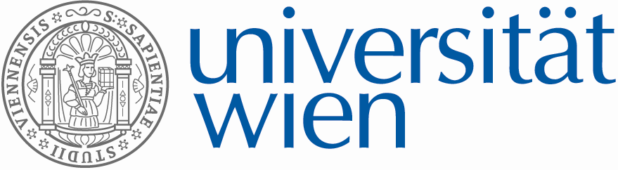
NICLAS FOR MINORITIES
New International Constitutional Law & Administrative Studies – Summer School 2012

APPLICATION FORM

Please read the following considerations and the information given at www.univie.ac.at/niclas (section “SummerSchool”, “NICLAS 2012”) carefully before completing and signing this application form.

I. Conditions of Participation:

1. Participation in the NICLAS Summer School Program is restricted to students of the partner universities involved including exchange students currently enrolled at these Universities:
University of Vienna; Université Libre de Bruxelles; Masaryk University Brno; Free University of Berlin; Goethe University Frankfurt/Main; University of Paris 1 Panthéon-Sorbonne; Andrassy University Budapest; Central European University Budapest (CEU); European University Institute Florence (EUI); University of Vilnius; University of Leiden; Pan-European University Bratislava (PEU); Jagiellonian University Cracow.

2. Participants have to be in their forth year of study or higher (postgraduate students/Ph.D students) and study in one of the following subjects areas: law (priority), political science, economy, international relations, European studies and other fields of study related to NICLAS).

3. Participation is limited to four students from each partner university. The partner universities apply a common selection policy, including academic excellence, international experience, gender equality, and equality of people with disabilities.

4. Participation is free of tuition charges. Travel and accommodation costs are covered by NICLAS (not for students enrolled at the hosting partner university PEU in Bratislava!).

5. Students selected for participation are expected

- to attend and actively contribute to the preparatory course offered at each partner university during spring semester 2012 (preparation of case studies according to the summer course program)
- to attend and actively contribute to the two week summer school from the July 9-21, 2012 in Bratislava (at PEU)

6. NICLAS is supported by the VICAJOP e-Learning platform (using OLAT) of the University of Vienna: http://vicajop.ned.univie.ac.at/. Students will profit from a blended learning approach while participating in the preparation and main summer session actively.

7. Participation in NICLAS is part of the official course program of the partner universities involved. Participating students are granted full academic recognition: NICLAS comprises 6 ECTS credits. 3 credits are granted by the partner universities for attendance of the preparatory course during spring semester at the home university. Additional 3 credits are granted by NICLAS Summer School upon successful completion of the summer course program.

8. Please send your application (including all necessary supporting documents indicated below, section IV.) to the local NICLAS coordinator at your home university as listed on the webpage (http://www.internationalconstitutionallaw.net/niclas_2012) and contact the same, locally responsible persons for further information on the application procedure at your home university.

II. Please complete the following sections carefully:

Personal details
Male Female
Title:
First name:
Surname:
Street:
Zip code:
City:
Country:
Nationality:
Year of birth:
Email:
Mobile phone:

Study background
Status at University of Vienna:
Regular Student Exchange student (e.g. ERASMUS)
Matriculation number:
Field(s) of Study:
Law Political Science Other (please indicate):
Year of study:
Degree program you are currently following:
Bachelor (B.A.) Master (LL.M, Mag. etc) Doctorate (Ph.D., Dr.)
Have you successfully completed courses in:
Constitutional Law International Law European Law
Comparative Law Other relevant courses (please indicate):

International Experience (e.g. ERASMUS, postgraduate studies, internships, etc.):

Extra curricular activities (Cultural, social or other activities with a European dimension):

III. Statement of Motivation (max 1 page):

IV. Documentation

Your application has to be supported by the following documents and sent (via e-mail or
conventional post) to the NICLAS coordinator at your home university indicated above (sec. I.):

DEADLINE for sending full applications is Jan 29, 2012!

CV (the use of the official Europass CV template is obligatory, max. 3 pages including
photograph; see:
http://europass.cedefop.europa.eu/europass/home/vernav/Europasss+Documents/Europass+CV/navigate.action)

One letter of recommendation (by a university teacher)

Transcripts of record (showing successful completion of the relevant courses as
indicated above)

Additionally, please give evidence of international experience and extracurricular activities as
indicated above (if applicable).

V. Confirmation

I confirm that the information supplied in this form is correct. I accept the terms and
conditions of participating in the NICLAS Summer School outlined in section 1 of this
document and on the NICLAS webpage:
http://www.internationalconstitutionallaw.net/niclas_2012

